Happiness

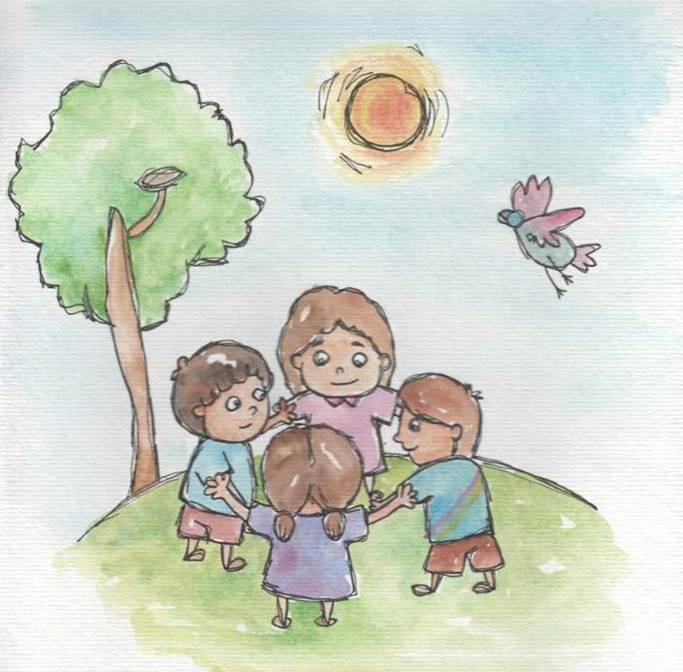

- When I have love and peace inside, happiness just comes.
- Happiness is having fun with my friends.

- Happiness is knowing I am loved.

- When I do good things, I am happy with myself.

- Good wishes for everyone make me happy inside.

- I can give happiness to everyone with my good wishes.

- I can give happiness to others with words that are like flowers, not thorns.
- I can give happiness to others by sharing.

From Living Values Education Activities for Children Ages 3-7 years © 2019 Association for Living Values Education International - www.livingvalues.net

