
Download Living Values Education Materials
Living Values Education is a ‘not-for-profit’ organisation and provides 'download' materials free of cost.
- VbA – The Key to a Better Life
- Materials For Schools
- Materials For Living Green Values
- Rainbow Booklet Values Library
- Materials For Businesses
- Materials For Distance Programmes

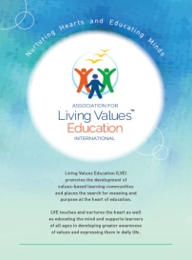
Distance Association for Living Values Education International Brochure - Read the ALIVE brochure and discover an overview of our organisation, its vision and aims, and how the Living Values Education Approach may be used in a wide variety of settings and ways including in schools, at home, and to support care for the environment.

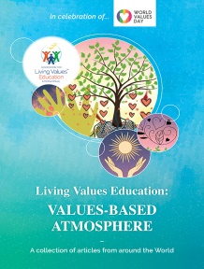
- Value-based Atmosphere Book - Responses from the LVE international community have allowed us to publish this beautiful 52-page book dedicated solely to the LVE Approach and to the Values-based Atmosphere. (desktop or phone version).

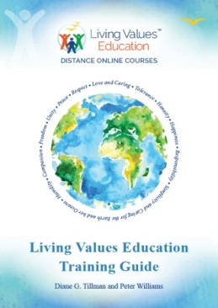
LVE Educator Training Guide -The Training Guide delivers all the techniques and skills required to feel confident to facilitate activities and workshops using the Living Values Education materials with community groups, schools, families, etc. The Guide provides professional advice, recommendations as to how to be a successful facilitator. Learn about ALIVE, Living Values history, the resources available to you, and to benefit from http:// livingvalues.net website.

Materials for Schools
Designed to address the whole child/person, Living Values Education activities engage people of all ages in exploring, experiencing and expressing values so they can find those that resonant in their heart, and build the social and emotional skills, which enable them to live those values.
The universal values explored are of Peace, Respect, Love, Cooperation, Happiness, Honesty, Humility, Responsibility, Simplicity, Tolerance, Freedom, Unity and more.
The initial set of five books known as the Living Values Education series are:
- Living Values Education Activities for Children Ages 3–7
- Living Values Education Activities for Children Ages 8–14
- Living Values Education Activities for Young Adults
- Living Values Education Parent Groups: A Facilitator Guide
- LVE Educator Training Guide

These Books are Available from Amazon

Rainbow Booklet Series - Values Activities for Children Ages 3-7, 8-14 and Young Adults – for download
Recognising the many challenges faced by teachers today with all ages of young people we created a Library of Values Activity booklets which are essentially ‘classroom aids’ providing ideas, using activities to assist in dealing with specific classroom issues, capturing student imagination, participation and discussion, perhaps bringing our young people to a different; more caring and responsible space.
Each value activities booklet of approx. 40-56 pages is easily printed on school printer as A5 booklet/pocket book size, landscape, 2 up, colour cover and b/w inside. Alternatively, you could download the files and order your choice of booklets from your local photocopy shop (one colour) for about $3 each.
Download Rainbow Booklets Library Overview – For Ages 3-7, 8-14, Young Adults
Introduction and Overview, Part B Appendix, Unit 1 Peace, Unit 2 Respect, Unit 3 Love and Caring, Unit 4 Tolerance, Unit 5 Honesty, Unit 6 Happiness, Unit 7 Responsibility, Unit 8 Simplicity and Caring for the Earth and her Oceans

Classroom & Workshop Support Materials
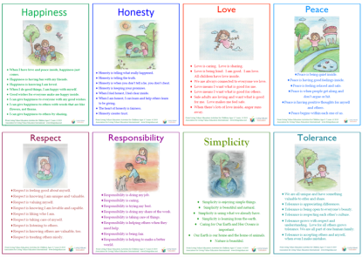
Posters for Children and Young People
Living Values Education posters are Reflection Points for each value. They are offered to assist and remind students and others seeking values awareness the various qualities of each value. For hand-outs can be printed as an A4 page in colour and also be increased in size to A3 (bigger) for display posters in the classroom. Available in Word or .pdf.
Download Posters: The .docx versions allow for language translation.

Download FREE Songs in mp3 format
Download FREE Stories. The stories were chosen because of their relevance to a particular value. Each pdf file states the values unit and lesson in which the story is included; the name of the story and author are stated in the relevant lesson of the book.

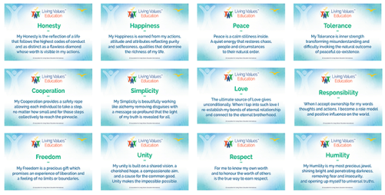
Living Values Education Values Cards
The simple values cards (setup as six per A4 page) are used as reminders for what the values offer to us and we offer to the values. Ideal for printing off and using one value each day for a week to remind ourselves of the treasure they can bring to our lives. The values cards are ideal for creating a point of focus in group situations, passing around and sharing with one another about what the particular value means to us, thus opening the doors for mutual discussion and self-discovery.
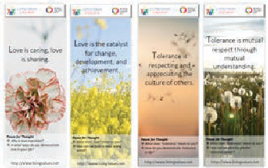
LVE Bookmarks
Living Values Education offers a set of 12 bookmarks to be used in a multitude of ways; for daily reflection, questions to ask ourselves, a gift for practical use, even to use on display as posters in the home or classroom.

Living Green Values, Activities for Children and Young Adults
These Living Green Values activities are intended to help young people be more aware of the importance of taking care of the Earth and her resources. Part of that process is awakening love for nature and her creatures and learning about specific ways that they can help be a friend to the Earth.

Rainbow Booklet Library
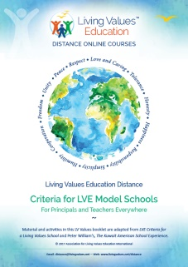
eBooks download for reading online or self-print option and copying. Provide Activities For Everyone – Teachers, Care Givers, Parents, Individuals, Special Interest Areas, Living Values for Self and Community Development. Information and requirements for becoming a LVE based school.
Living Values Education The Living Values School Experience
Living Values Education Criteria For LVE Model Schools
Living Values Education Improving Facilitation Skills

Materials for Businesses
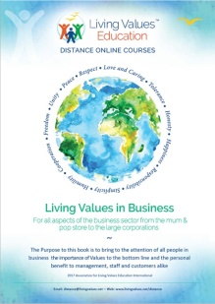
- Living Values in Business – For Associates, Focal Points and Facilitators
This 52-page book is to bring to the attention of LVE facilitators the opportunity of assisting business of all types and size to the importance of values in business, to provide support information and how the material can be used.
- Living Values in Business – For Owners / Managers/ Employees
Of all the Values one would assume are important in the business environment perhaps the Value of Happiness would not be the first that comes to mind, yet as the booklet demonstrates the Values-based Atmosphere is intrinsic to the wellbeing of very organisation from the mom and pop corner grocery store to the large corporate environment.
LVE Parenting Guide
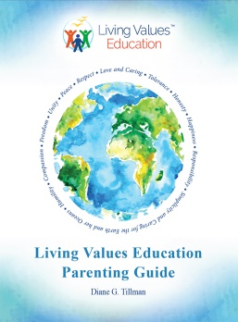
LVE Parenting Guide - Suggestions and activities are shared to help parents help children, from toddlers to teens, use values to handle their challenges as well as to deal with the concerns of bullying and social media. Chapters are offered on balanced family life in regard to screen time, preventing sexual abuse and drug use, rebuilding relationships that appear broken and taking care of yourself are also included.

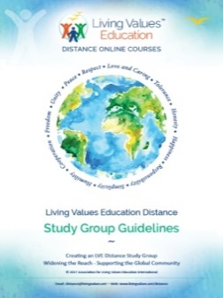
Materials for LVE Distance Programmes
- Living Values Education Distance - Values Activities
- Living Values Education Distance - Study Groups
- Living Values Education Distance - Facilitator Training
- Living Values Education Distance - Self-Reflection

Living Values Education recognises that it is not practical for much of the world’s population to attend workshops and participate in organised Living Values Education activities due to cost, time, and travel requirements. Through this Distance opportunity, Living Values Education encourages and extends Living Values Education Distance Online Courses to individuals, families, and communities.
The resources in this section allow you to engage in activities directly yourself, among your family, friends, and colleagues, or even students in the classroom or workplace.
The materials for Living Values Education Distance Home Study include:
- Distance Facilitator Training - Join LVE as a facilitator - 12 week Certificated Course
- Distance Values Activities for Groups and Individuals – For Adults, Families, and Groups – a colourful 52-page Rainbow Booklet – participation book of activities, drawn from Living Values Education for Young Adults.
- Distance Personal Journal – a 97-page book will help you record each of the activities and give you something to look back on.
- Values-based Atmosphere Book desktop & download version or phone version –what a Values-based Atmosphere means for educators and how it can be yours.
- Audio-Guided Meditations
- Distance Self-Reflection – Your 12 Week Values Personal Development booklet
- Distance Study Group Guidelines – A guide for Study Group hosts on 'how to' manage effective group activities.

Find all FREE Download options – http://livingvalues.net/resources

